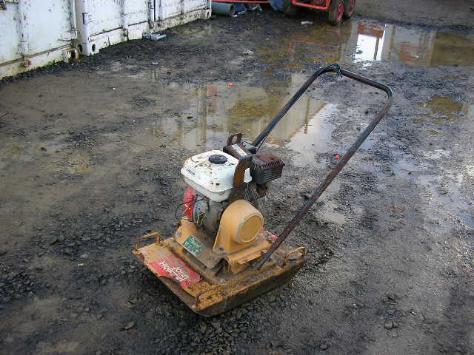 | Hazard Information Sheet
  Equipment: | Compaction
 | Equip Type: | Plate Compactors
 | Generic Description or  Specific Make / Model: | Plate Compactors
 | Type: | Petrol/Diesel
 | Other Details

Operator Requirements: | Operators must be trained and competent to use this equipment safely.
Purpose For Which This Equip Is Designed: | A pedestrian operated machine designed to compact soil in narrow trenches and around obstacles such as columns

Hazards & Risks:
Control Measures:
Crushing (Squashing)  Unexpected movement of plant | Operator is responsible to never leave machine running unattended.
Coming into contact with compactor plate. | (i) Operator responsible to wear appropriate PPE e.g. protective foot and eye wear plus particle masks in dusty conditions etc.  (ii). When using a forward/reversing motion near buildings etc. operator to ensure sufficient room to manoeuvre to prevent being pinned against walls etc. when changing direction.
Manual Handling:  Body strain if equip requires manual lifting. | Ask for assistance to lift or carry the machine. Keep a straight back when lifting and use leg muscles to take weight of machine.
Noise:  Exposure to noise. | Personnel working with or in the vicinity of this equipment to wear suitable hearing protection.

Disclaimer: In fulfilment of its statutory obligations, (ARS) & John Holland has taken what it considers to be all reasonable precautions and exercised due diligence to ensure that it has provided all relevant information on the safe use of the plant. However, except as required by law and only to the extent so required, (ARS) & John Holland does not make any representation, warranty or undertaking, express or implied, as to, or accept any responsibility or liability for, the accuracy or completeness of, or any errors in or omissions from, this Hazard Information Sheet. Except as required by law and only to the extent so required, neither (ARS) & John Holland nor any of its respective directors, officers, agents, or employees shall in any way be liable directly or indirectly to any person or body for any loss or damages, costs or expenses whatever arising out of or in connection with the information contained in this Hazard Information Sheet. | Date: 19/06/06
Equipment: | Plate Compactors

Hazards & Risks: | Control Measures:
High Temperature or Fire:  Refuelling: When refuelling, sparks, flames, hot engine can ignite fuel. | Operator is responsible to shut engine down prior to refuelling.  Refuel in a well ventilated area. Ensure that there are no naked flames in the area. DO NOT SMOKE. Avoid spilling fuel and collect any fuel run off.
Other Hazards:  Injury caused by using machine on a sloped surface. | Operator responsible to operate machine diagonally on sloped surfaces to avoid machine slipping toward the bottom edge during operation.
Other Hazards :  Injury caused by moving motion of the machine. | Operator is responsible to ensure that no other person is close to the machine while is being started or while it is in operation.
Suffocation:  Use in a confined space can cause asphyxiation. | Operator/user responsible to use machine in well ventilated area.

Disclaimer: In fulfilment of its statutory obligations, (ARS) & John Holland has taken what it considers to be all reasonable precautions and exercised due diligence to ensure that it has provided all relevant information on the safe use of the plant. However, except as required by law and only to the extent so required, (ARS) & John Holland does not make any representation, warranty or undertaking, express or implied, as to, or accept any responsibility or liability for, the accuracy or completeness of, or any errors in or omissions from, this Hazard Information Sheet. Except as required by law and only to the extent so required, neither (ARS) & John Holland nor any of its respective directors, officers, agents, or employees shall in any way be liable directly or indirectly to any person or body for any loss or damages, costs or expenses whatever arising out of or in connection with the information contained in this Hazard Information Sheet. | Date: 19/06/06

